 “**The Prince William - Fauquier Voter”**

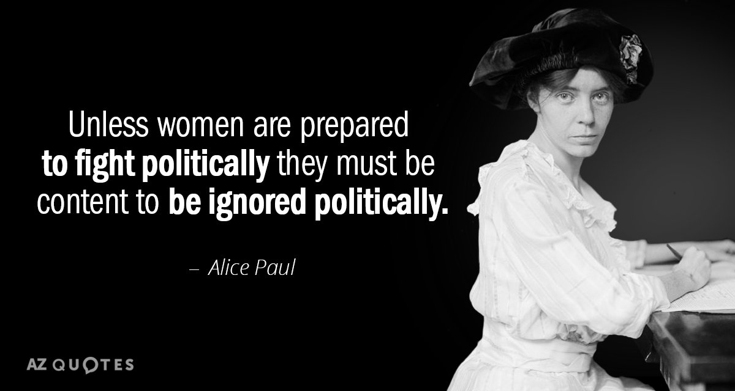July 2022 Newsletter

**From the Desk of the President ….**

**Janet Gorn, LWV-PWFA President**

**Stepping up the League’s Membership Recruitment and Renewal Game**

**Are You Getting the Biggest Benefit from Your Membership?**

The LWV-PWFA League is at the midpoint in the 2021-2023 Biennium Cycle, having just completed FY 2021-2022. As you write your FY 2022-2023 membership renewal check or new member check, reflect for a moment on the long list of your membership benefits, the many volunteer participation opportunities, and why you joined the League. Let me count some of the whys.

**First**, is the camaraderie and friendships of fellow members who are a part of a network of dedicated volunteers who are empowered and share a passion for creating positive change on the local, state, and national levels;

**Second**, our members serve as leaders in the community, shaping the issues that ensure community health, vibrancy, equity, inclusiveness, sustainability, and resilience; and

**Third**, Our League’s voice is part of the work of one of the most respected and important grassroots organizations in the United States.

**Don’t miss out on all these benefits, write that check today.**

**Each One Bring One New Prospective Member**

|  |  |  |  |  |  |  |  |  |  |
| --- | --- | --- | --- | --- | --- | --- | --- | --- | --- |
| |  |  |  |  |  |  |  |  |  | | --- | --- | --- | --- | --- | --- | --- | --- | --- | | |  | | --- | |  | |  | |  | |  | |  | | --- | |  | |  | |  | | |

**The Supreme Court and Roe v. Wade**



Connie Gilman, Vice President

On June 24, 2022, the Supreme Court overturned [Roe v. Wade](https://www.history.com/topics/womens-rights/roe-v-wade) and Planned Parenthood v. Casey. It is important for all of us to realize that LWVUS has a stand and will be mobilizing with national partners and providing consistent direction for Leagues that are looking to plug into state and local protests and engage in the national conversation. The LWVUS website has more information and provides talking points for members to use when discussing this controversial topic.

*It is important to remember only the President of the LWV-PWFA may make statements for our local league. However, ALL league members may share their concerns as an independent citizen.*



**Press Release** / Last Updated: June 24, 2022

WASHINGTON — Today the League of Women Voters of the United States President **Dr. Deborah Turner** and CEO **Virginia Kase Solomon** issued the following joint statement in response to the 6 – 3 Supreme Court decision of Dobbs v. Jackson Women’s Health Organization, which overturns the constitutional right to abortion as recognized for nearly 50 years in the landmark cases of Roe v. Wade and Planned Parenthood v. Casey:

“Today’s ruling strips women and those who may become pregnant of their bodily autonomy and will have devastating — and immediate — consequences across the country. While the Court’s opinion was expected, its harm is extreme and real. When women and those who can become pregnant can no longer make reproductive decisions for their own bodies, they are no longer equal individuals in our democracy. This harm will exacerbate societal inequalities and fall disproportionately on people of color and low-income communities already facing egregious obstacles to health care.

"The decision foreshadows the erosion of other well-established Constitutional rights including marriage equality, access to contraception, and the right to engage in private, consensual intimate conduct.

"The dissenting Justices get it exactly right: today’s majority opinion is an assault on the constitutional guarantee to equal protection of the laws and the right to due process. With this decision, BIPOC, LGBTQIA+, and other historically marginalized communities have no guarantees that their civil rights will be protected.

"The League of Women Voters stands in our power with our reproductive partners and all persons who fear the dangerous consequences of this decision. We will use our anger to fight in the legislatures, in the courts, and in the streets. We call on our elected leaders at the state and federal levels to act swiftly to restore bodily autonomy to all people.

"Women hold the power to create a more perfect democracy. We will not stand by as constitutional rights are stripped away, one by one. Women’s rights are human rights, and we will continue to fight until the right to abortion is restored. Our lives depend on it.”

The League of Women Voters filed an amicus in the case of Dobbs v. Jackson Women’s Health Organization. Learn more about the case [here](https://www.lwv.org/legal-center/dobbs-v-jackson-womens-health-organization).

 PRESS CONTACT: Shannon Augustus | 202-768-9578 | saugustus@lvw.org

|  |
| --- |
|  |
| |  |  |  |  |  |  |  |  |  | | --- | --- | --- | --- | --- | --- | --- | --- | --- | | |  | | --- | |  | |  | |  | |  | |  | | --- | |  | |  | |  | | |

|  |  |
| --- | --- |
| |  | | --- | | **Democracy in Action**  **Trish Freed, Treasurer**  Dear Prince William - Fauquier Area League of Women Voters Member,  It’s July and time to renew your chapter membership for the calendar year 2022!  The League has been busy planning events for the coming year, and there will be many interesting opportunities for fellowship, advocacy, and voter outreach. The League looks forward to receiving your membership renewal and we hope you’ll join in our activities and programs. Don’t delay and miss out on the many benefits from participation in League activities and programs! There are opportunities to:  ·     become involved in the political process,  ·     gain knowledge and experience through the study and discussion of timely and important topics,  ·     discover new interests, develop new skills, and learn about crucial issues in the community, and  ·     contribute valuable services to the community.  To access the membership renewal form, please click on the following link [LWV-PWFA Membership Form 2022-2023](https://r20.rs6.net/tn.jsp?f=001T3zBgffK41Bb4gZPb90r75Ji6A4drh5ZhjsibDj2a7_4cCbhYA1Ypmj861KQf08qNgZYtVxx2QnmV23ZmPDCrkocyjAGd3dFKlFLrwicxWphRTIXE3G7Y1spUGjYU2n2rce88Y_T9TFLIlnCKjOm_9DZcHQID2skgm6lVkzM20kdzgWDJlCGsEYBSm_Yih6r&c=Ntm9HFpSLQKE2ySKjgw8d7cZSyN8iF1LJFiTFKbepk_QI0c7XzMURg==&ch=RR8IVzw3DUhnruoFBtGLmewWyVVNdIIz_7GVrc-vKpTiZAlYw6lsiA==)(you may need to hold the “Ctrl” key at the same time as you click on the link). Please choose the membership category and payment method of your choice, per options on the form.  Our goal is to receive all renewals by the end of June.   The League welcomes your interest and encourages you to fill out the volunteer activities section near the bottom of the membership form. To find out more, please check out our Calendar of Events at [https://www.princewilliamlwv.org/calendar-of-events/](https://r20.rs6.net/tn.jsp?f=001T3zBgffK41Bb4gZPb90r75Ji6A4drh5ZhjsibDj2a7_4cCbhYA1Ypuh6ieVTdNYKXVt_HE7SaJYTohqalT1xKdPEIUP1s2KJsOsh7w8ASrvfgdScAX0Y-mv4MezP54A6Z9KbATCYH3IlNo_kEffJCnM-h22Q5BIs7ykQR0rt9D6ulA7w1D8VVw==&c=Ntm9HFpSLQKE2ySKjgw8d7cZSyN8iF1LJFiTFKbepk_QI0c7XzMURg==&ch=RR8IVzw3DUhnruoFBtGLmewWyVVNdIIz_7GVrc-vKpTiZAlYw6lsiA==).   Our mission is to empower voters and protect democracy. We can’t do it without you! Thank you for your continuing contributions and support.   Best Regards,  Patricia Freed  Treasurer, LWV of the Prince William-Fauquier Area  **NOTE TO MEMBERS: Don't set this aside - get to it now! You can use PayPal or write a check, but don't delay!** | |

|  |  |  |  |  |  |  |  |  |  |
| --- | --- | --- | --- | --- | --- | --- | --- | --- | --- |
| |  |  |  |  |  |  |  |  |  | | --- | --- | --- | --- | --- | --- | --- | --- | --- | | |  | | --- | |  | |  | |  | |  | |  | | --- | |  | |  | |  | | |

*Join other League members for an enjoyable outing and a great book discussion!*

July 12, 11:30 – 1 P.M., Effingham Manor Winery

Talking to Strangers: What We Should Know about the People We Don't Know,  [Malcolm Gladwell](https://www.amazon.com/Malcolm-Gladwell/e/B000APOE98/ref=dp_byline_cont_ebooks_1)

This is an intellectual adventure, a challenging and controversial excursion through history, psychology, and scandals taken straight from the news. Something is very wrong, Gladwell argues, with the tools and strategies we use to make sense of people we don’t know. And because we don’t know how to talk to strangers, we are inviting conflict and misunderstanding in ways that have a profound effect on our lives and our world.

|  |  |  |  |  |  |  |  |  |  |
| --- | --- | --- | --- | --- | --- | --- | --- | --- | --- |
| |  |  |  |  |  |  |  |  |  | | --- | --- | --- | --- | --- | --- | --- | --- | --- | | |  | | --- | |  | |  | |  | |  | |  | | --- | |  | |  | |  | | |

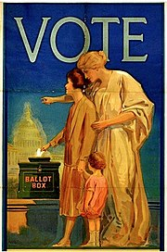It is never too early to plan for some fun!

What:   **August Sips and Civility event**

When:  Thursday. August 25, 2:30 to 4 pm

Where:  Montclair Library

Lena Berrios Gonzalez has invited us to the Montclair Library for a special traveling exhibit from the State Library.

**We Demand: Women’s Suffrage in Virginia** Explore the history that led to the ratification of the 19th Amendment granting women the right to vote. Walk through a series of 8 double-sided panels and an interactive kiosk, a traveling exhibition from the Library of Virginia with support from the Task Force to Commemorate the Centennial Anniversary of Women’s Right to Vote. 

Lena will also have a special book display and possibly an interactive station re suffrage.  (They also have fabulous art exhibits and a pollinator garden)

We will serve iced tea and lemonade on the Veranda of this beautiful library.

If anyone wants to have dinner or more substantial sips, we can go around the corner to Wine Styles or Giorgios.

|  |  |  |  |  |  |  |  |  |
| --- | --- | --- | --- | --- | --- | --- | --- | --- |
| |  | | --- | |  | |  | |  | |  | |  | | --- | |  | |  | |  | |

**Congratulations!**

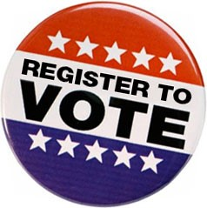The *Prince William Committee of 100 Certificate of Appreciation Awarded to Carol Noggle, LWV-PWFA Voter Services Director*

The Committee of 100 at their Annual Meeting Awarded Carol Noggle its *Certificate of Appreciation*. Carol has been a member of our League of Women Voters since 2007 and is one of the most dedicated members, especially in the areas of voter registration and election education. The award is based on her long and very impressive accomplishments in these areas, especially in her efforts to register high school seniors and engage them in the election process. Also noted at the awards ceremony were Carol’s previous service as the League’s liaison and lobbyist to the General Assembly, her continued efforts to keep the community up-to-date on Virginia General Assembly legislative successes and challenges, and her distribution of advocacy information to League members.

|  |  |  |  |  |  |  |  |  |  |
| --- | --- | --- | --- | --- | --- | --- | --- | --- | --- |
| |  |  |  |  |  |  |  |  |  | | --- | --- | --- | --- | --- | --- | --- | --- | --- | | |  | | --- | |  | |  | |  | |  | |  | | --- | |  | |  | |  | | |

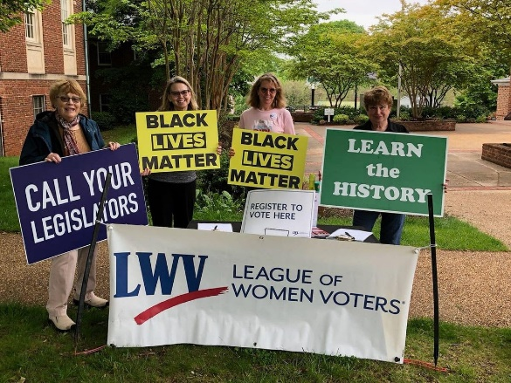

The following Black Lives Matter Vigil article by Barbara Amster appeared in the *June 2022 LWV-VA eVoter*

**“***LWV of the Prince William-Fauquier Area Celebrated its sponsorship of the 100th consecutive Black Lives Matter Vigil on May 14th***.”**

Not a demonstration, not a protest, the Black Lives Matter Vigil began two years ago, after the murder of George Floyd, and has just passed its 102nd consecutive week.

Pat Riley, Miggy Strano, Ruthann Litchfield and Barbara Amster are pictured.

Vigil participants sometimes exceeding 120 people, have stood through sunshine, rain, and snowstorms to share a plea for racial equality and justice, every Saturday from 10:00 am to 10:45 am, in front of the Warrenton Courthouse.  The LWV of the Prince William-Fauquier Area has proudly been a cosponsor of the Vigil, along with the NAACP, the Interfaith Council, the Afro-American Historical Society, and two other non-partisan organizations, and has maintained a continuing voter registration table every Saturday morning.  Under a large League of Women Voters banner, the LWV-PWFA has passed out information on upcoming primaries and elections, restoration of felons' rights, fair housing, and other LWV positions, while registering voters and winning good will for the League.  In fact, this visibility has fostered a boom in membership from Fauquier County.

The League also furnished speakers several times for the post-Vigil gathering after the signs saying "Learn the History", "Racial Justice", "Black Lives Matter" , "Let's Have a Conversation", etc. had been put away.  A typical speaker, this time the President of the NAACP, Dr. Ellsworth Weaver, noted that participants should "have no problem in fulfilling the mission of seeking justice, helping others in need of better jobs, housing, and health care."  Sadly, at the same time Dr. Weaver was speaking, Payton Gendron was on his way to the Tops Friendly Market in a Black neighborhood of Buffalo, NY, intending to kill as many African-Americans as possible.  Racism is alive and thriving and the Vigil is needed now more than ever.

Citizens from Warrenton and the surrounding areas, many of whom come into town for the Farmers' Market, a block away from the courthouse, seem to enjoy the Vigil.  They are greeted by smiles and gentle “good mornings” as they walk among Vigil members and sometimes stop to ask questions or make comments.  Some have even stayed, picked up signs, and joined the Vigil!  The event has been peaceful since it began, gaining respect of local law enforcement and political leaders.  The Warrenton Town Council and police have been assured of our appreciation for their kind words and the police presence to contain the few "protestors" who show up to intimidate us.   At the February meeting, Town Council members opposed a demand that the Vigil be shut down, each member offering what they knew about the Vigil and affirming the group's right to be in the public eye, as "democracy at work."

As a participant, who has represented the League at all but six of the Vigils, I can attest to the feeling of heightened awareness and commitment to racial justice among Vigil members and passers-by.  More African Americans started driving by on Saturday mornings than had typically been seen in downtown Warrenton in past years.  When parents point out our signs to the children in their car, it heartens us to think that the Vigil is helping to start conversations in families as well as among townspeople.  Some African-Americans have stopped to say they are encouraged to see the outpouring of concern from a mixed group of Black and White people.  When this happens, I am prouder than I ever have been to be a member of the League of Women Voters, and of helping to uphold some of the most fundamental LWV positions.

|  |  |  |  |  |  |  |  |  |  |
| --- | --- | --- | --- | --- | --- | --- | --- | --- | --- |
| |  |  |  |  |  |  |  |  |  | | --- | --- | --- | --- | --- | --- | --- | --- | --- | | |  | | --- | |  | |  | |  | |  | |  | | --- | |  | |  | |  | | |

 **MAJOR CHANGES AFFECT THE 2022 ELECTIONS**

Carol Noggle, Voter Services Director

With major changes in Prince William and Fauquier County district boundaries, and because of a significant increase of residents in PW, our 2022 elections have significant changes from the past. Instead of 3 Representatives to Congress, PW will elect only 2 Representatives –one from the 10th and one from the 7th District -- with significant boundary changes. Most important for voter information is any change to precincts and polling places. Prince William has had to add 10 additional precincts to meet the requirement of the maximum number of voters allowed in each.

**For November:**

* Election Day, November 8th, may provide easier participation for some because it is designated as a Virginia State Holiday.
* The Voter Registration deadline will be extended to November 8th. (I will check but I believe a person who registers that day will need to vote with a provisional ballot.)
* Mail-in absentee ballots MUST have a Witness Signature this year because there is not the emergency that was declared last year.
* Drop boxes for Absentee Ballots will be allowed.
* There is no change in the identification requirement; that is, a Photo ID is not required. The list of what can be used is available on the LWV-PWFA website.

|  |
| --- |
|  |
| |  |  |  |  |  |  |  |  |  | | --- | --- | --- | --- | --- | --- | --- | --- | --- | | |  | | --- | |  | |  | |  | |  | |  | | --- | |  | |  | |  | | | |

**League Meetings are open to all members!**

Board of Directors Meeting, 3rd Tuesday of the month, 7:00-9:00 pm

General Meetings and Events, 3rd Sunday of the month, 2:00-4:00 pm

**LWV-PWFA Website**: [www.princewilliamlw.org](http://www.princewilliamlw.org)

**LWV-PWFA Email**: [lwvpwfa@gmail.com](mailto:lwvpwfa@gmail.com)

|  |  |  |  |  |  |  |  |  |
| --- | --- | --- | --- | --- | --- | --- | --- | --- |
| |  | | --- | |  | |  | |  | |  | |  | | --- | |  | |  | |  | |

**LWV-PWFA Board of Directors**

President, Janet Gorn jgorn4@verizon.net

Vice President, Connie Gilman conniewg51@gmail.com

Treasurer, Trish Freed freedsrt@Verizon.net

Recording Secretary, Cynthia Chambless [cynthia57@comcast.net](mailto:cynthia57@comcast.net)

Membership Outreach Director, Cathy Ring ring.cw@gmail.com

Membership Records Director, Sheila Arrington arringtgl@verizon.net

Volunteer Director, Judy Hingle jkhingle@gmail.com

Program and Events Director (Acting), Janet Gorn jgorn4@verizon.net

Voter Services Director, Carol Noggle cnogg@comcast.net

Meeting Co-Directors, Miriam Anver anvermr@gmail.com

Laura Feld-Mushaw smushaw@comcast.net

Fauquier Unit Coordinator, Ruthann Litchford r.litchford@live.com

Advocacy Coordinator cnogg@comcast.net

Communications Coordinator, Carol Proven carol.proven01@gmail.com

Media Relations Coordinator, Pat Reilly reillypat18@gmail.com

Book Discussion Chair, Connie Gilman conniewg51@gmail.com

Newsletter Chair, Connie Gilman conniewg51@gmail.com

|  |  |  |  |  |  |  |  |  |
| --- | --- | --- | --- | --- | --- | --- | --- | --- |
| |  | | --- | |  | |  | |  | |  | |  | | --- | |  | |  | |  | |



[This Photo](https://www.gbcnv.edu/cte/newsletters.html) by Unknown Author ilicensed under [CC BY-NC-ND](https://creativecommons.org/licenses/by-nc-nd/3.0/)

Please send in ideas for the September Newsletter by August 25th. Better yet, submit an article, ask some questions, share a joke!

Contact Newsletter Chair Connie Gilman [conniewg51@gmail.com](mailto:conniewg51@gmail.com) if you have questions, ideas, or that joke!

**The *League of Women Voters of the Prince William Fauquier Area*** is a nonpartisan political organization. Our members are women and men who make a visible difference. They serve as community leaders who are using their experience in making democracy work and creating lasting change in the communities where we live.

**Meeting Tomorrow’s Challenges Today**

**Empowering Voters Defending Democracy**

**JOIN US ….**

To be part of a network of dedicated volunteers who are empowered and share a passion for creating positive change on the local, state, and national levels.

**JOIN US ….**

To serve as a leader in your community! Shape the issues that ensure community health, vibrancy, equity, inclusiveness, sustainability, and resilience.

**JOIN US ….**

To add your voice to the work of one of the most respected and effective grassroots organization in the United States.

<http://www.PrinceWilliamLWV.org>