The League of Women Voters of the Prince William Fauquier Area is a nonpartisan political organization. Our members are women and men who make a visible difference. They serve as community leaders who are using their experience in making democracy work and creating lasting change in the communities where we live.

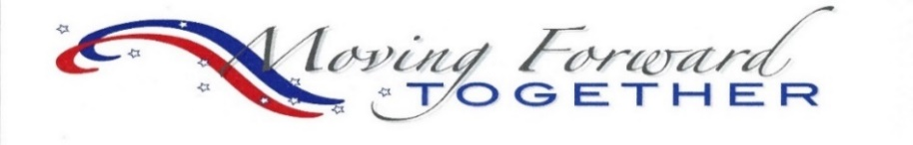

Meeting Tomorrow’s Challenges Today
Empowering Voters Defending Democracy
JOIN US ….
To be part of a network of dedicated volunteers who are empowered and share a passion for creating positive change on the local, state, and national levels.

JOIN US ….
To serve as a leader in your community! Shape the issues that ensure community health, vibrancy, equity, inclusiveness, sustainability, and resilience.

JOIN US ….
To add your voice to the work of one of the most respected and effective grassroots organization in the United States.
http://www.PrinceWilliamLWV.org
LWVpwfa@gmail.com

