GUIDANCE
November 2, 2022

LWVUS Structure Transformation Plan

The League Structure Transformation Plan is a multi-faceted, long-term initiative to address the League’s organizational capacity at all levels.
pacity at all levels.

Our Long-Term Path: The Transformation Roadmap
A study and assessment of the League begun in 2016 culminated in the Transformation Roadmap, introduced at the 2018 National Convention. This Roadmap was formulated with input from Leagues at all levels as an action plan for building a renewed, larger, and more unified and effective organization.
League leaders had shared that too much time and talent are spent on duplicative administrative efforts that could be better spent on building our power through advocacy, education, and voter services. Following Convention 2020, a diverse group of local, state, and national leaders explored these challenges and solutions with an eye toward helping us more effectively pursue our mission. These leaders made up the LWV Structure Taskforce.
Many of the recommendations outlined in the Transformation Roadmap have been acted on over the past few years. The LWV Structure Taskforce developed the Structure Transformation Plan.

The Structure Transformation Plan:
Build Power Together
The League Structure Transformation Plan is an initiative to grow League membership in number and diversity, strengthen our grassroots power, and bolster our ability to empower voters and defend democracy.
The Diversity, Equity, and Inclusion lens was central to the taskforce’s work in preparing this plan.
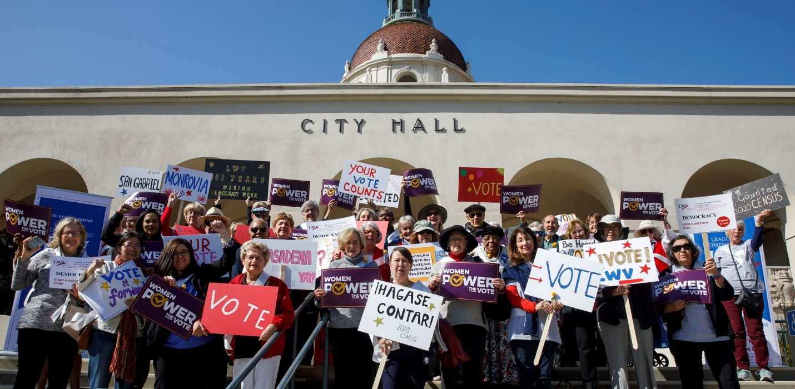
I am ecstatic about the transformation that the League is undertaking, as it allows us to respond more powerfully to protect our democracy! – Tracy Adkison, League Structure Taskforce Member

Info Sessions
- Check back for future scheduled opportunities for engagement

Table of Contents
- Part 1: Formalize League and Membership Rights & Responsibilities
- Part 2: Upgrade Our Membership Mechanics
- Part 3: Invest in State Leagues
  - Focus 1: Increase state League capacity
  - Focus 2: Simplify our federated structure
- Frequently Asked Questions

Part 1: Formalize League and Membership Rights & Responsibilities
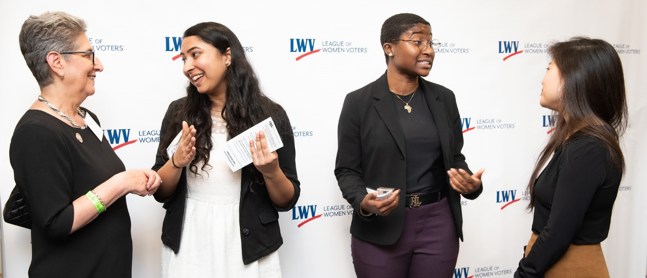
To strengthen the League’s grassroots power, LWV members need a unified understanding of what it means to be a League member. Likewise, state and local Leagues need a unified understanding of what it means to be affiliated with the nationwide League of Women Voters.
This is the time to act boldly for the future of the League and our democracy by strengthening the partnership between Leagues and their members. – Jessica McDonald, League Structure Taskforce Member
WHAT | - League-wide Member Rights & Responsibilities explaining benefits and expectations of membership  - League Rights & Responsibilities for state/local Leagues that outlines what it means for a League to be affiliated with LWV
WHY | LWV has never had an agreement that declares what Leagues can expect from LWVUS. Additionally, we need a way for members to have a unified understanding of what LWV membership means.
WHEN | Both draft policies were available for Leagues to view and submit comments from May 2022 to Oct. 2022. UPDATE NOV. 2022: LWVUS is revising the policies based on the feedback received.

Part 2: Upgrade Our Membership Mechanics
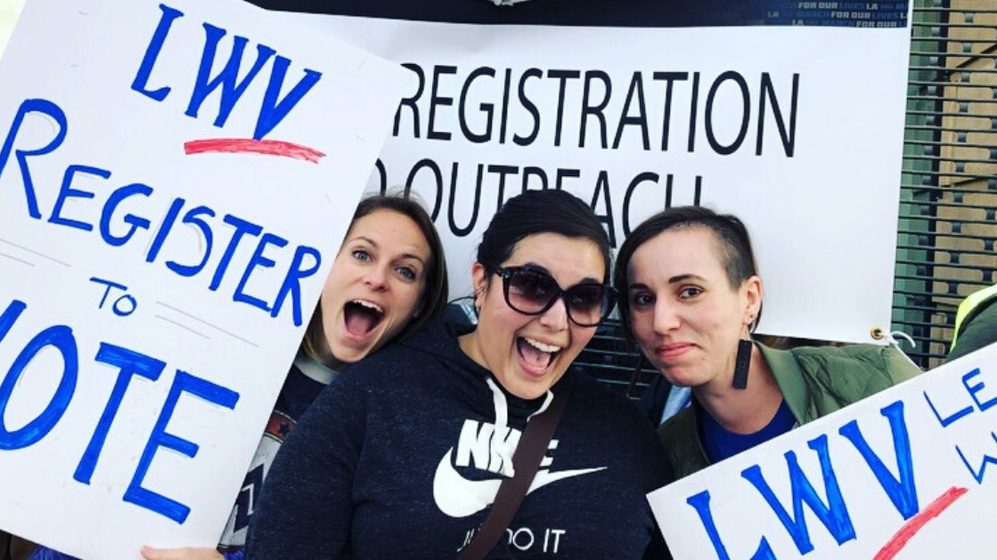
We need to grow our membership exponentially, across all diverse communities, so that we have the power necessary to fulfill our mission of ensuring that every citizen has an equal seat at the table of American democracy.
This is a wonderful opportunity to grow League membership and League resources. This plan to build a stronger, more unified League will help us to build power together. – Becky Simon, League Structure Taskforce Member
WHAT | - A consistent and aligned membership system across all levels of League that will eliminate financial barriers to participation, create an equitable division of dues between levels of League, and overall simplify mechanics of joining the League  - A system to gather, aggregate, and share demographic and member experience data across all Leagues
WHY | Members are a vital source of organizational power for LWV, carrying out the League’s mission on the ground and serving as the organization’s strongest base of support. We need to grow our grassroots membership in number and diversity so that our organization looks like the people we serve and has the collective power to ensure all voices are heard.
WHEN | At LWV National Convention 2022, delegates adopted bylaws changes to enact updates to membership mechanics. Find the updated bylaws here. UPDATE NOV. 2022: Implementation of the new membership mechanics is currently targeted for early 2024. State and local League leaders will be asked for input as the system is developed.

Part 3: Invest in State Leagues
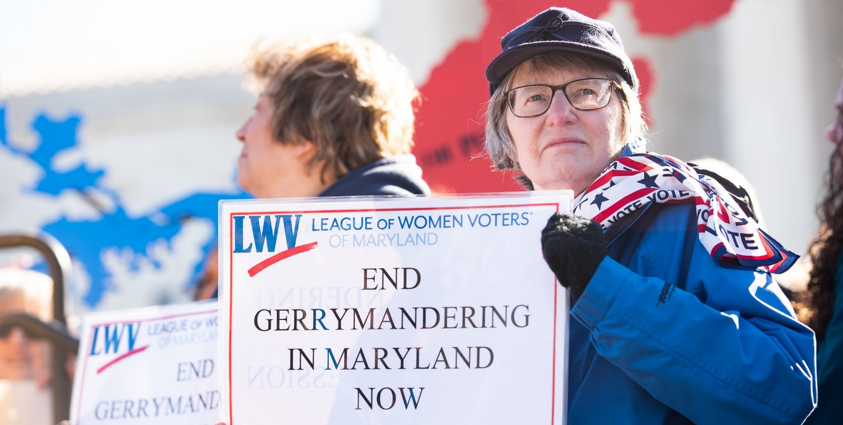
State Leagues are a vital part of LWV’s grassroots power and strength. The fight for voting rights has turned to the state level, and the League is well-positioned to lead as a 50-state national organization. We need to build power at the state-League level to meet this critical moment for democracy.
The fight for voting rights is largely fought at the state level. Democracy won't prevail if state Leagues aren't equipped with the resources they need to win. – Jessica Lowe-Minor, League Structure Taskforce Co-chair

Focus 1: Increase state League capacity
WHAT | We must increase capacity for state Leagues sufficient to exercise political power within their legislature, support professional paid staff, build organizing strength, and support local Leagues.
WHY | The fight to ensure free, fair elections must be waged at the state level because state legislatures most often control critical election-related issues: voter access, redistricting, government ethics, transparency, campaign finance, and more. State Leagues are a vital part of LWV’s grassroots power and strength. They provide essential communications, organizing, advocacy, and administrative support to local Leagues and members in their state.
WHEN | Building capacity in all state Leagues is a multi-year, long-term commitment. LWVUS staff will assess and define what’s needed to implement a state League capacity-building program over the next decade.

Focus 2: Simplify our federated structure
WHAT | Ensure that Leagues can maintain focus on the mission. This includes:  - Investing in membership growth to increase state and local League capacity  - Allowing Leagues to prioritize mission work over administrative tasks  - Developing a plan to empower state Leagues, with their newly built capacity, to support and manage local League administrative burden
WHY | League leaders often share that their efforts are channeled in the wrong places; instead of attending to administration and management, they want and need to focus the grassroots activities that can help them have impact. Given the extreme challenges currently facing our democracy, the League must ensure that its members are fully empowered to engage in mission-impact work and are released from bureaucratic, administrative tasks.
WHEN | At LWV National Convention 2022, delegates passed forward-thinking budget elements to build and implement a state League capacity growth plan. UPDATE NOV. 2022: LWVUS will work with all levels of League to build out the long-term plan for implementation over the next decade.

Frequently Asked Questions
As the League moves forward with these recommendations, many details will need to be worked out and addressed. The “how” of implementing these recommendations will be a highly collaborative process, and there will be many opportunities for state and local League leaders to get involved and provide input over the next months and years.
- Are the suggestions made in the Transformation Roadmap from 2018 still valid? How can members unfamiliar with the Transformation Roadmap learn about it?
Absolutely! The suggestions that came out of the Transformation Roadmap, such as building a more inclusive and representative organization, increasing our capacity at all levels, and strengthening our League network, are still very valid today. Growing our impact and growing our membership numbers are critical to our ability to fulfill our mission, and we need to ensure that the maximum amount of time and precious volunteer resources are spent on mission-impact work rather than on administrative tasks.
The Transformation Roadmap can be found here. League members are also encouraged to review the Executive Summary. The Transformation Roadmap is the foundation for these recommendations, in addition to continuing discussions that the LWVUS Board and League Structure Task Force have had with League leaders from around the country in various settings, including Councils and Conventions.
- What is a unified dues structure?
A unified membership dues structure will require the LWVUS Board to set one dues model across the country. This dues structure will also include options for members to “pay what you can,” and will likely allow members to support all three levels of League by paying more than the standard dues. The dues amount has not been determined, and it will be set after careful consideration of current local and state League funding levels related to dues and per member payment (PMP), and in consultation with state Leagues.
- Can my League opt out of the membership structure (i.e. join at all levels) recommendation?
No. The goal of this recommendation is for all Leagues to have the same easy-to-navigate membership structure, and that requires across-the-board implementation. It should be easy for people to find (and join!) the League of Women Voters. Also, a major benefit of this recommendation is that it allows for economies of scale: the cost of building/maintaining one quality membership system is much less than it is for each of the 800+ local and state Leagues to build their own, individual systems. Additionally, this system will reduce administrative burden for all Leagues because they won’t have to do constant roster updates, and it will enable the elimination of PMP.
- How will dues revenue be shared between local, state and national? And what about Per Member Payment (PMP)?
PMP would be eliminated and net dues revenue would be split between all levels of League at the time of collection (i.e. when a member’s dues payment is processed). The exact formula for this split is still being developed; however, it will be one in which LWVUS receives a third or less of the total net membership revenue.
- Are you suggesting that everyone will join at the national level and then will be directed to state/local organizations near where they live?
We propose that anyone be able to join or renew League membership at any level (via any website) and that the dues revenue and member data would be shared automatically to the local, state, and national Leagues.
- Will these changes cause my League to lose autonomy?
No. These changes are being recommended with the goal of empowering local and state Leagues to attract more members and increase their League's capacity. Local and state Leagues will maintain their local decision-making authority and will have less administrative burden to deal with, thus freeing their leaders and membership to have more time to engage in the "real" work of League: empowering voters and defending democracy.
- What are some examples of administrative tasks that are burdening local Leagues?
Over many years, we’ve received feedback from Leagues that an inordinate amount of volunteer time is spent on tasks such as roster maintenance, accounting, filing corporate annual reports, completing IRS paperwork, searching for insurance, and other tasks that are required for organizational and legal compliance, but are not mission-specific. Through this initiative, many of those tasks would, over time, be eliminated or greatly reduced on the local League side and would be completed by paid professionals on the state League side.
- How long will all of this take? When will it “go live?”
This is a complex process that will require a long implementation period. A detailed plan for launch will be developed and then submitted for League leaders’ information at the 2023 National Council. (Items such as the membership structure process [i.e. “join at all levels”] would be rolled out sometime after that).
Tags:
Policies & Guidance,
Bylaws,
Membership Engagement,
Membership Recruitment

Transformation Roadmap
LWVUS has published a “Transformation Roadmap” that includes specific action steps to be implemented. It is a synthesis of many threads of work, including input from Leagues across the country, interviews with internal and external stakeholders, review of the larger nonprofit environment and the professional expertise of consulting firms.

